Number of subarrays with sum zero
Problem
Given an array a[] of size n. Our task is count the number of subarrays with sum zero.

Example
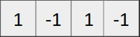
Subarrays with sum zero are:
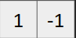, 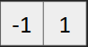, , 

Number of subarrays with sum equal to zero are 6.

Brute force approach
- Iterate over all the subarrays using nested loops, simultaneously calculate sum and maintain a variable cnt. Increment count whenever sum adds up to zero.

Time Complexity: O(n²)

Optimized approach
- Compute prefix sum array. For the above example, It will look like
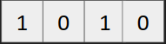
- Main idea: For an array of prefix sum if a value repeats in prefix sum array at indices i and j, it denotes sum of elements from indices i+1 till j is zero.
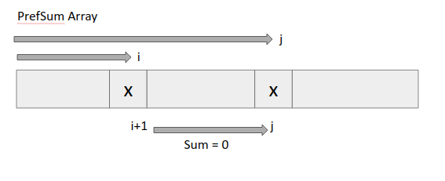
So, we have to find the number of ways in which we can choose two same valued elements in the PrefSum array. (Special case for PrefSum[i]=0, as they add upto zero from starting index)
- Declare a map (say freq) denoting frequency of elements in the prefix sum array.
map<int,int> freq;
- Iterate over the PrefSum array and just do
freq[PrefSum[i]]++;
- After our freq map is created, then apply permutation and combination formula to choose 2 elements from the group of m identical items. (^{m}C₂) for each key.

Code
